Airport Management System

**Mini Project Report**

***Submitted by***

Naman Chitkara-RA1911029010046 Atul -RA1911029010053

Zuber -RA1911029010050

Course: 18CSC3003J Database Management Systems



**COLLEGE OF ENGINEERING AND TECHNOLOGY**

**S.R.M. Nagar, Kattankulathur, Chengalpattu District**

**May 2022**

**Declaration**

I/We declare that “Airport Management System” is the bonafide work of “Naman Chitkara-RA1911029010046 Atul-RA1911029010053 Zuber -RA1911029010050]” .

**Signature of the students**

# ABSTRACT

Airport Management System is a web application, developed to maintain the details of passengers, security personnel and flight staff in an airport. It maintains the information about the personal details of the passengers and their bookings. The passengers have the ability to generate and download their flight ticket in a pdf format. The details of the security personnel and the flight staff for each flight is also stored. They can log in and perform their respective functionalities such as clearing and checking in passengers and generating the flight report.

**TABLE OF CONTENTS**

|  |  |
| --- | --- |
|  | **Abstract** |
|  | **Table of Contents** |
| **1** | **Introduction** |
| **2** | **Description of the aim/objective and applications of the work and software used** |
| **3** | **Tables and Front end (if used) Screen shots** |
| **4** | **Conclusion and Future Work** |
| **5** | **References** |

# INTRODUCTION

This system is an application developed in python3.5. It is user-friendly and very intuitive. It is fast and can perform many operations which are necessary for an airport. It is simple to understand and can even be used by people who are not even familiar with the workings of an airport.

This software package has been developed using HTML, CSS and Javascript at Front End and Django at Back End with Microsoft SQL Server database.

This version of the software has a multi-user approach. For further enhancement or development of the package, user’s feedback will be considered.

# SOFTWARE USED

* HTML
* CSS
* JAVASCRIPT
* DJANGO
* MYSQL DATABASE

# TABLES SCREENSHOTS

1. TABLE - Worker:

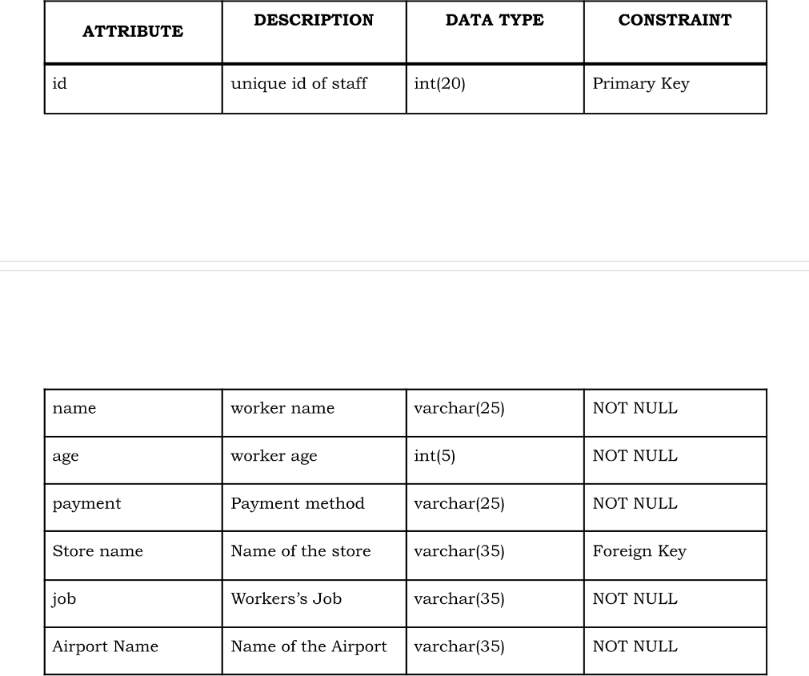

1. TABLE - Airport

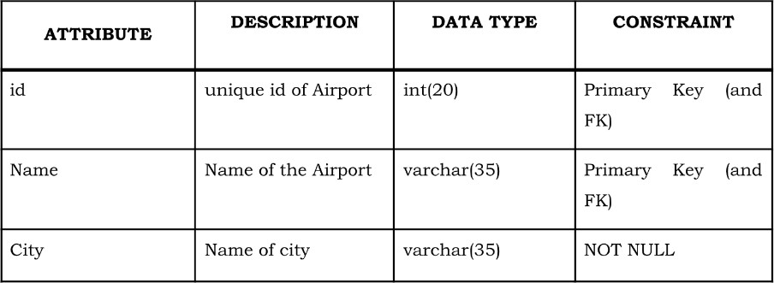

1. TABLE - Flight

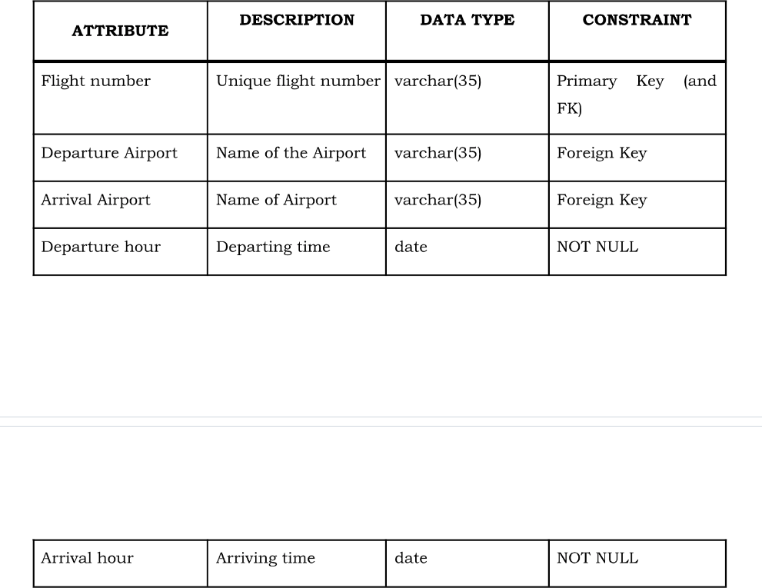

1. TABLE - Ticket

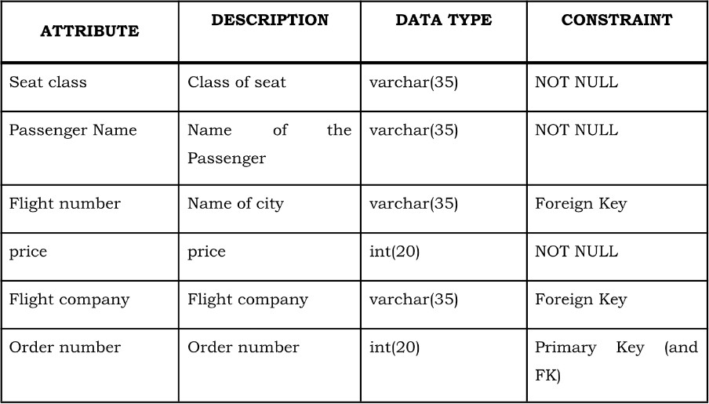

1. TABLE - Supplier:

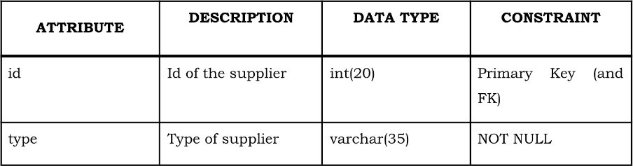

1. TABLE - Booking Agent:

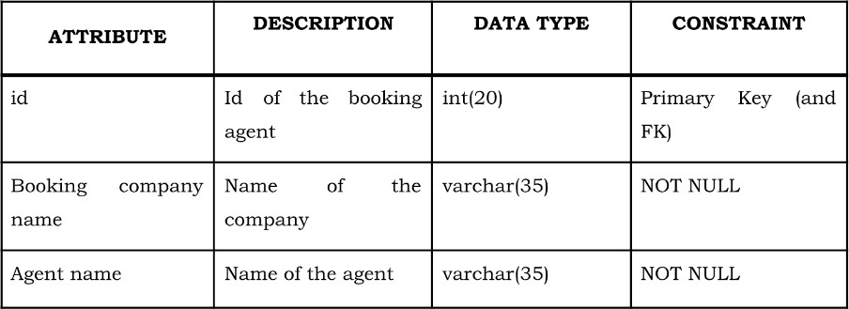

1. TABLE - Flight Company:

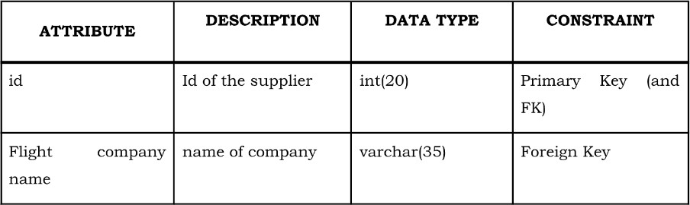

1. TABLE - Store:

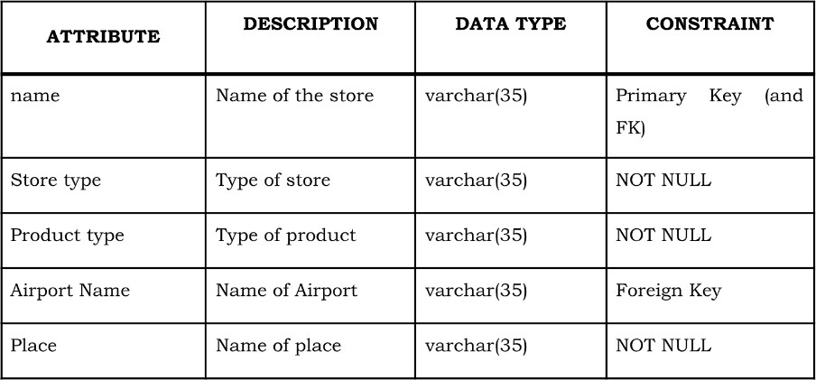

FRONTEND SCREENSHOTS

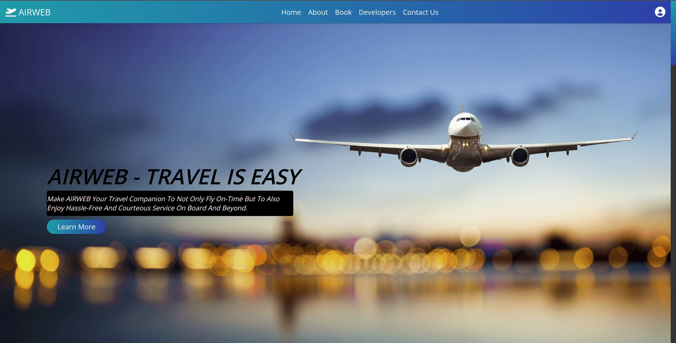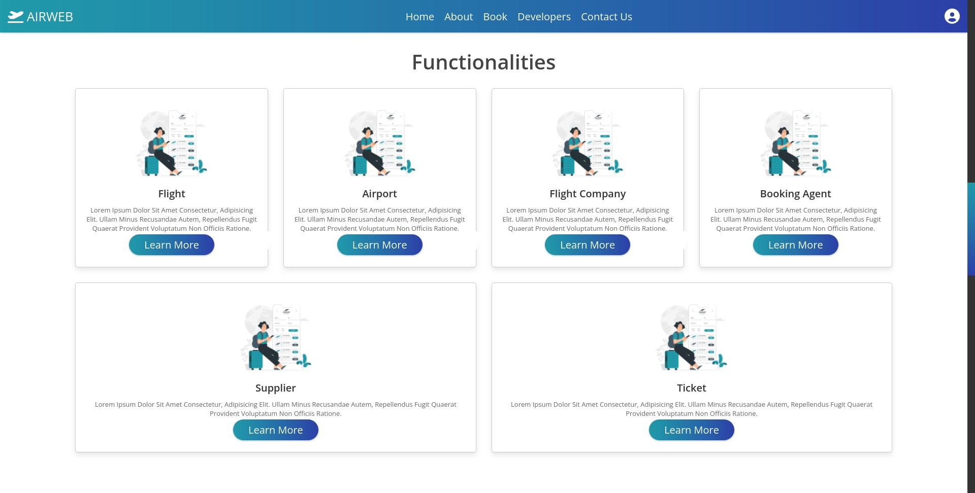

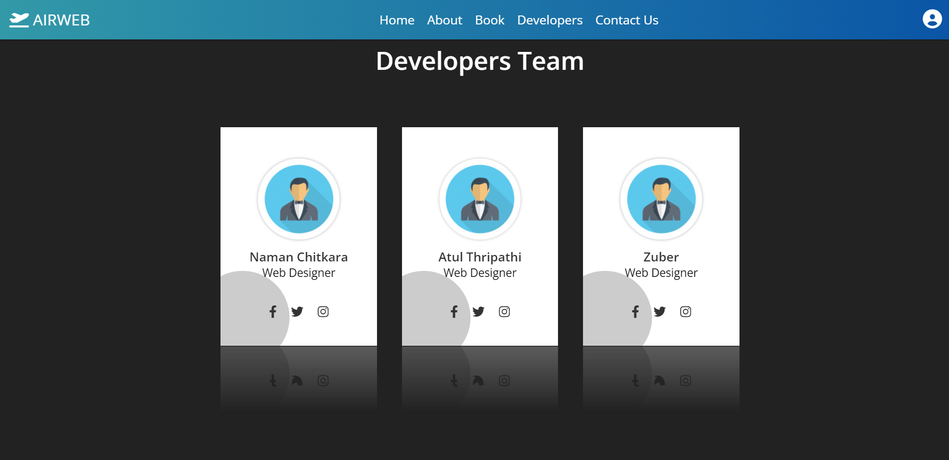

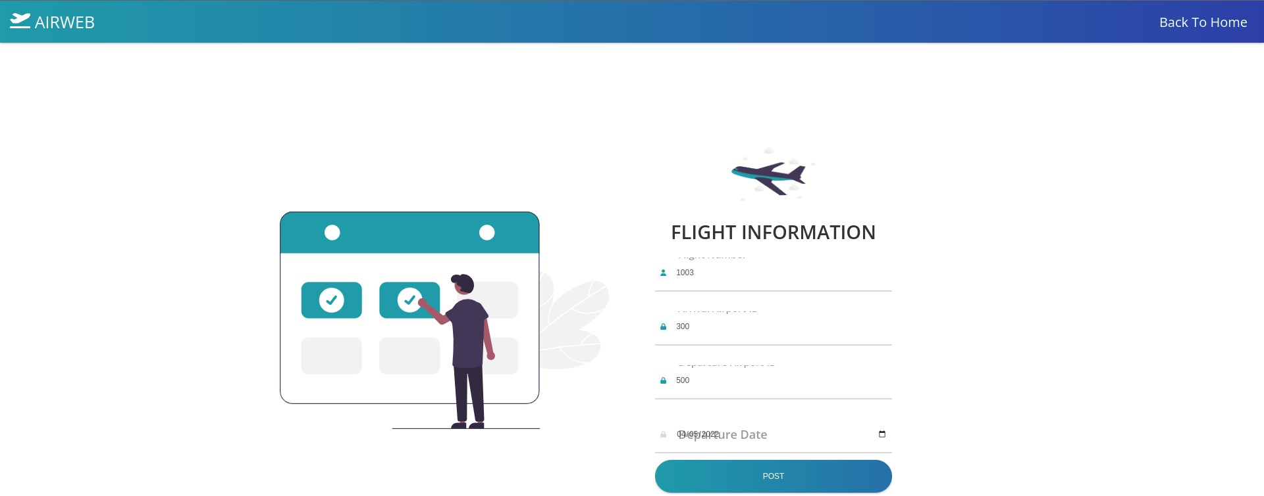

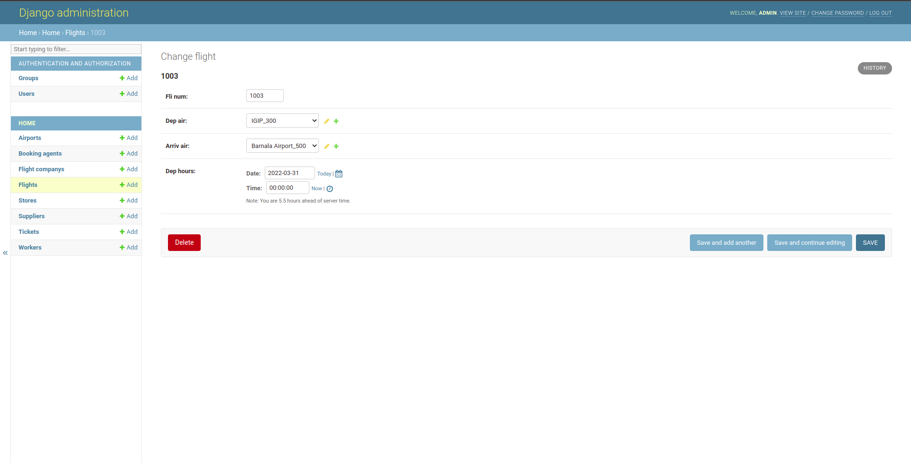

CONCLUSION

The Airport Management System is user-friendly and very intuitive. The Airport management system that is designed is very fast and can perform many operations which are necessary for an airport. The model takes care of all the duplicates and ambiguous data. It is simple to understand and can even be used by people who are not even familiar with the workings of an airport. The database is fully secure and can be accessed by the admin only, this reduces chances of data manipulation by any third party.

For future work or development of the package, user’s feedback will be considered.

REFERENCES

* [https://www.altexsoft.com/blog/travel/airport-technology-management-o](https://www.altexsoft.com/blog/travel/airport-technology-management-operations-software-solutions-and-vendors/) [perations-software-solutions-and-vendors/](https://www.altexsoft.com/blog/travel/airport-technology-management-operations-software-solutions-and-vendors/)
* [https://www.airport-suppliers.com/supplier/airport-information-systems-a](https://www.airport-suppliers.com/supplier/airport-information-systems-ais/) [is/](https://www.airport-suppliers.com/supplier/airport-information-systems-ais/)
* [https://www.navayugainfotech.com/assets/brochure/airport-managemen](https://www.navayugainfotech.com/assets/brochure/airport-management-system.pdf) [t-system.pdf](https://www.navayugainfotech.com/assets/brochure/airport-management-system.pdf)